Claudiu Moise

Project Log 1

Project Link: https://gitlab.com/xonotic/xonotic

Contribution:
Creating video tutorials so as to reduce the barrier to entry for new comers to the project.
Updating the map making engine on the wiki.
Creating documentation.

Challenges:
Finding time to work on the project while deeply engaged in my undergraduate thesis project.
Learning the video editing software
Learning how to use the map making tool with a lack of good explanation/documentation.
Mediocre response to my contribution.
Communication:
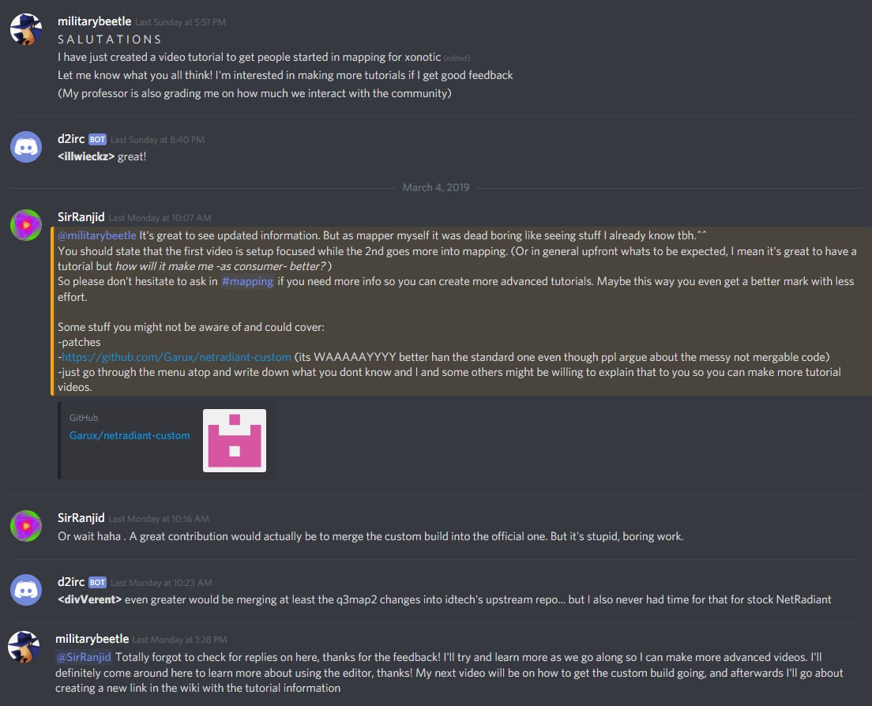

Work Completed so Far:
Learned how to get the map making kit/game up and running. Then filmed and edited the footage using Lightworks.
Created Part 1 of 2:
https://www.youtube.com/watch?v=J02HEoM8iTs&feature=youtu.be

